INNOLOFT VENTURES | InnoTrack Daily Report | 20-Day Internship Program

DAILY INTERNSHIP REPORT

SECTION 1 — STUDENT INFORMATION

Student Name | Nareddy.Shanmukha Nihal Reddy | VTU ID | 28683
Branch / Dept. | CSE(AI&DS) | Internship Day No. | 1
Date | 01/06/2026 | Track (1 / 2 / 3 / 4) | 1
Project Title |  | Mentor Name | JAYASRI

SECTION 2 — WHAT DID YOU LEARN TODAY?

Topic / Concept Learned
Learned Python environment setup, VS Code configuration, GitHub workflow, variables, data types, user input/output, f-strings, and basic Python programming concepts.

SECTION 3 — WHAT DID YOU BUILD TODAY?

Code / Output / Feature Built
Personal Information Program
name='NAREDDY SHANMUKHA NIHALREDDY'
age=19
college='VELTECH UNIVERSITY'
branch='CSE(AI&DS)'
CGPA=8.63
print(f'My name is {name}.I am {age} studying {branch} at {college} with {CGPA} CGPA')

Feature Built: Developed a Personal Information Display System using variables and f-strings to present user details in a formatted output.
OUTPUT
Age Calculator
birthyear=int(input("enter birth year:"))
if birthyear>2026:
print("invalid year")
else:
age=2026-birthyear
print(f'present age {age}')
print(f'age in 10 years: {age+10}')

Feature Built: Developed an Age Calculator that accepts the user's birth year, calculates the current age, and predicts the age after 10 years.
OUTPUT:
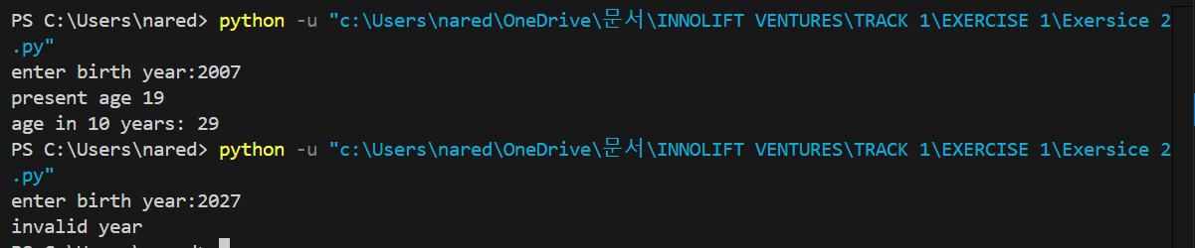
BMI Calculator
weight = float(input("Enter weight (kg): "))
height = float(input("Enter height (cm): "))

height = height / 100

BMI = weight / (height * height)

if BMI < 18.5:
print("Underweight")
elif BMI <= 24.9:
print("Normal")
else:
print("Overweight"

Feature Built: Developed a BMI Calculator that accepts weight and height as input, calculates Body Mass Index, and classifies the result into health categories.
OUTPUT:
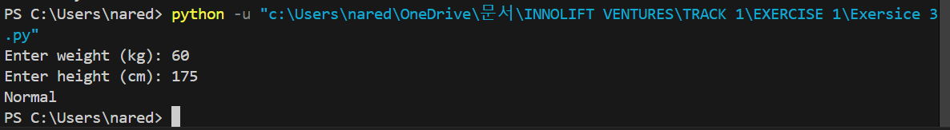

SECTION 4 — PROBLEMS FACED & HOW YOU SOLVED THEM

Error / Problem (e.g. ValueError when scaling — solved by dropping nulls first)
1.Difficulty understanding GitHub repository management and code upload workflow.
2.Incorrect BMI calculation results due to input format issues.
How I Fixed I
1.Learned the GitHub workflow and successfully uploaded project files.
2. Corrected the input format and verified the BMI calculation logic.

SECTION 5 — PLAN FOR TOMORROW

What will you do tomorrow?
Learn and practice conditional statements (if, elif, else).
Learn loops and functions through hands-on exercises.

SECTION 6 — LINKS & ATTACHMENTS

GitHub Repo / Commit Link | https://github.com/NSNihalreddy/VELTECH-SUMMER-INTERNSHIP-/tree/main/Innolift%20Ventures/Track%201/Day%201
Model Result / Colab Link | All Day 1 exercises were completed successfully and uploaded to GitHub with the required folder structure.
Deployed App Link (if any) | NA
Additional Notes | Successfully set up the development environment, completed all assigned exercises, and performed the first GitHub code upload. Gained practical exposure to Python programming fundamentals and version control workflows.

SECTION 7 — SELF RATING FOR TODAY

Area | 1 | 2 | 3 | 4 | 5
Understanding of today's concept | ☐ 1 | ☐ 2 | ☐ 3 | ☐ 4 | ☑ 5
Hands-on coding confidence | ☐ 1 | ☐ 2 | ☐ 3 | ☐ 4 | ☑ 5
Progress on my project | ☐ 1 | ☐ 2 | ☐ 3 | ☐ 4 | ☑ 5
Overall satisfaction with today | ☐ 1 | ☐ 2 | ☐ 3 | ☐ 4 | ☑ 5

